Proper Region Containment

Definition
# Source: AI Source: Provided by: [Data Path: Persons Table -> ID Column: 1, Name_En Column: Motasem Essam] -> From: [ChatGPT] on [7/25/2026]
Proper Region Containment is a type of geometric containment in which one region lies completely within another region, while the two regions are not equal.
If region $R_{1}$is properly contained in region $R_{2}$, we write:
$$\boxed{R_{1}⊊R_{2}}$$
This means:
- Every point of $R_{1}$belongs to $R_{2}$.
- $R_{2}$contains at least one point that does not belong to $R_{1}$.
Formally:
$$\boxed{R_{1}⊊R_{2} ⟺ R_{1}⊆R_{2}\text{ and }R_{1}≠R_{2}}$$
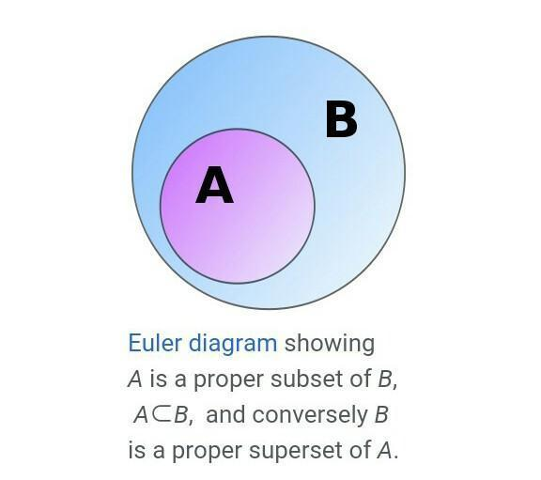
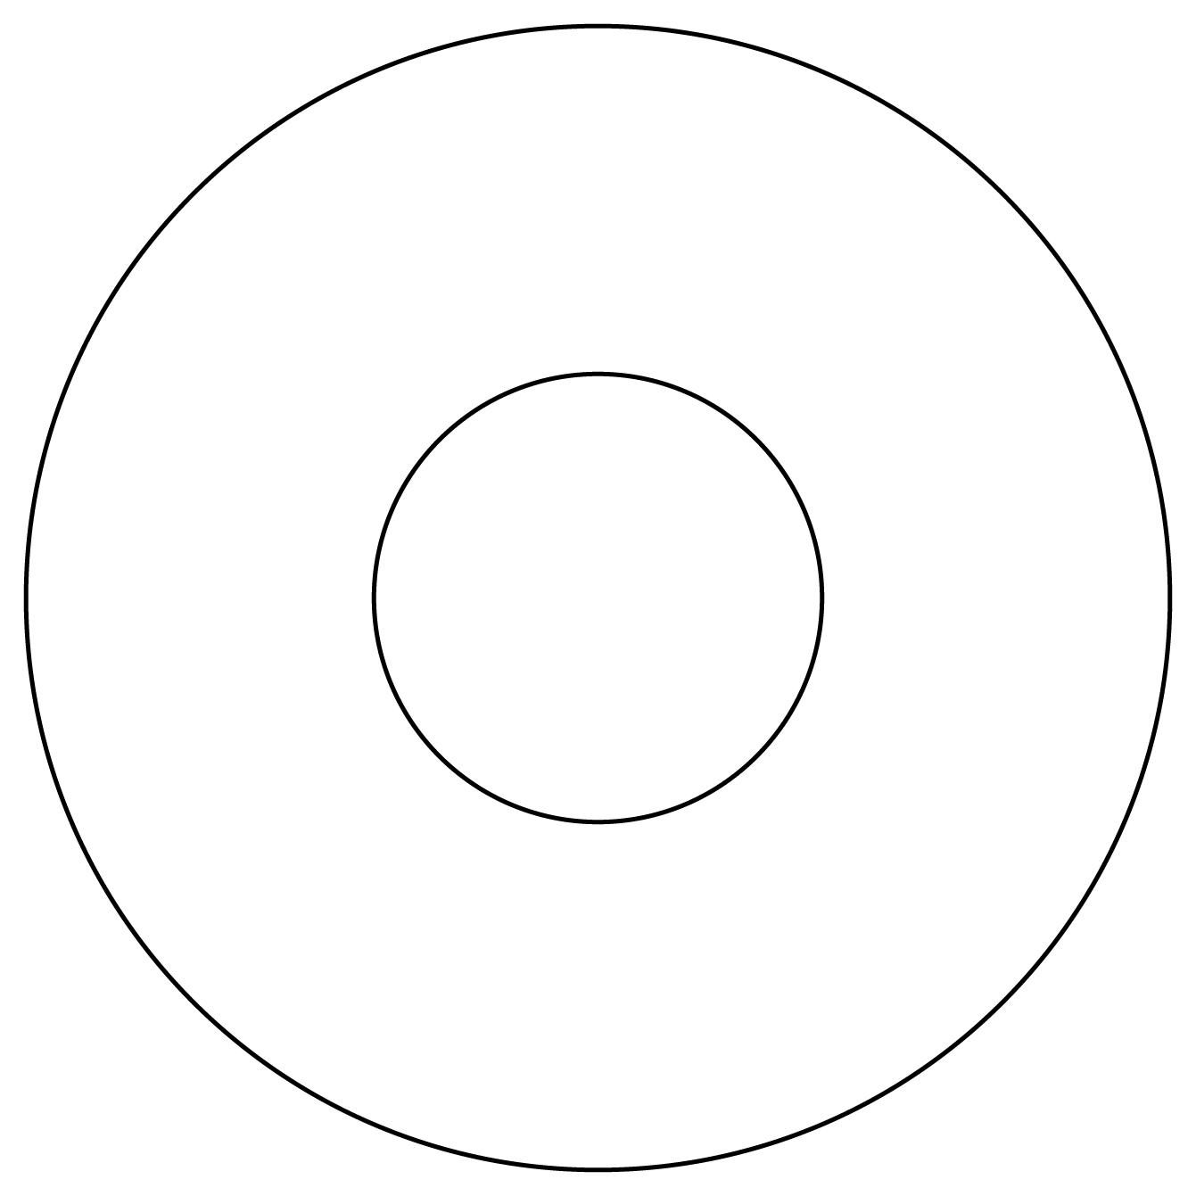
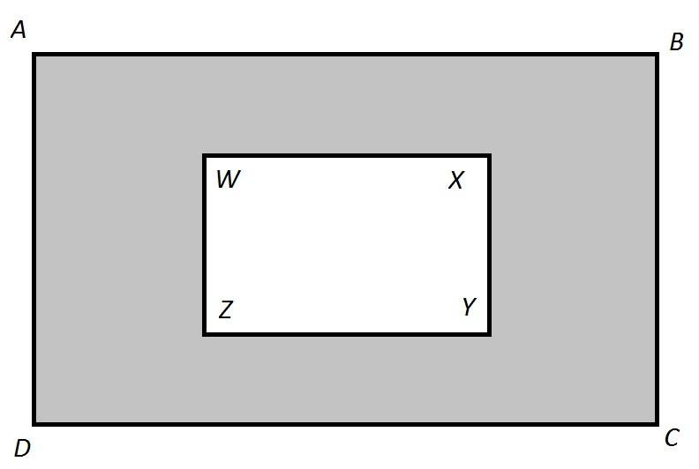
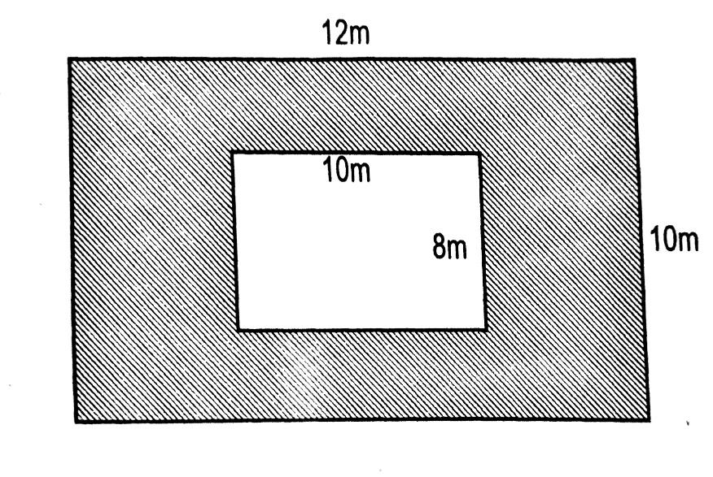

Purpose
# Source: AI Source: Provided by: [Data Path: Persons Table -> ID Column: 1, Name_En Column: Motasem Essam] -> From: [ChatGPT] on [7/25/2026]
Proper region containment is used to determine whether one region is strictly smaller in extent than another region and lies completely within it.
It helps distinguish:
- proper containment,
- equality,
- overlap,
- boundary touching,
- and disjoint regions.

Fundamental Concept
# Source: AI Source: Provided by: [Data Path: Persons Table -> ID Column: 1, Name_En Column: Motasem Essam] -> From: [ChatGPT] on [7/25/2026]
A region can be treated as a set of points.
Therefore, proper region containment follows the mathematical concept of a proper subset.
If:
$$R_{1}⊊R_{2}$$
then:
$$\boxed{\text{Every point of }R_{1}\text{ is in }R_{2}}$$
but:
$$\boxed{\text{At least one point of }R_{2}\text{ is not in }R_{1}}$$
So $R_{1}$occupies only part of $R_{2}$.

Mathematical Representation
# Source: AI Source: Provided by: [Data Path: Persons Table -> ID Column: 1, Name_En Column: Motasem Essam] -> From: [ChatGPT] on [7/25/2026]
Proper Containment
$$\boxed{R_{1}⊊R_{2}}$$
Equivalent Definition
$$\boxed{R_{1}⊆R_{2} \text{and} R_{1}≠R_{2}}$$
Pointwise Form
$$\boxed{P∈R_{1}⇒P∈R_{2}}$$
and there exists at least one point $Q$such that:
$$\boxed{Q∈R_{2} \text{and} Q∉R_{1}}$$

Fundamental Elements
# Source: AI Source: Provided by: [Data Path: Persons Table -> ID Column: 1, Name_En Column: Motasem Essam] -> From: [ChatGPT] on [7/25/2026]
A proper region containment relationship consists of:
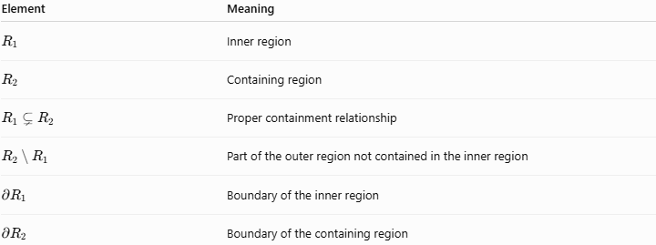
Element | Meaning
$$R_{1}$$ | Inner region
$$R_{2}$$ | Containing region
$$R_{1}⊊R_{2}$$ | Proper containment relationship
$$R_{2}∖R_{1}$$ | Part of the outer region not contained in the inner region
$$∂R_{1}$$ | Boundary of the inner region
$$∂R_{2}$$ | Boundary of the containing region

Example 1 – Circle Inside a Larger Circle
# Source: AI Source: Provided by: [Data Path: Persons Table -> ID Column: 1, Name_En Column: Motasem Essam] -> From: [ChatGPT] on [7/25/2026]
Consider:
$$R_{1}=\left\{\left(x , y\right)∣x^{2}+y^{2}≤4\right\}$$
and:
$$R_{2}=\left\{\left(x , y\right)∣x^{2}+y^{2}≤25\right\}$$
The first region is a disk with radius $2$, while the second is a disk with radius $5$.
Therefore:
$$\boxed{R_{1}⊊R_{2}}$$
Every point of the smaller disk belongs to the larger disk, but the larger disk contains many points that are not in the smaller disk.

Example 2 – Rectangle Inside a Larger Rectangle
# Source: AI Source: Provided by: [Data Path: Persons Table -> ID Column: 1, Name_En Column: Motasem Essam] -> From: [ChatGPT] on [7/25/2026]
Let:
$$R_{1}=\left\{\left(x , y\right) , ∣2≤x≤6 2≤y≤5\right\}$$
and:
$$R_{2}=\left\{\left(x , y\right) , ∣0≤x≤10 0≤y≤8\right\}$$
Then:
$$\boxed{R_{1}⊊R_{2}}$$
The smaller rectangle is completely contained within the larger rectangle.

Example 3 – Triangle Inside a Polygonal Region
# Source: AI Source: Provided by: [Data Path: Persons Table -> ID Column: 1, Name_En Column: Motasem Essam] -> From: [ChatGPT] on [7/25/2026]
If a triangular region lies entirely inside a larger polygonal region, then:
$$\boxed{△R⊊P}$$
provided that the triangle and polygon are not equal.
The triangle therefore forms a proper subregion of the polygon.

Proper Containment vs Equality
# Source: AI Source: Provided by: [Data Path: Persons Table -> ID Column: 1, Name_En Column: Motasem Essam] -> From: [ChatGPT] on [7/25/2026]
Proper containment requires the regions to be different.
Proper containment
$$R_{1}⊊R_{2}$$
means:
$$R_{1}≠R_{2}$$
Equality
$$R_{1}=R_{2}$$
means both regions contain exactly the same points.
Therefore:
$$\boxed{R_{1}⊊R_{2}⇒R_{1}≠R_{2}}$$
However:
$$R_{1}⊆R_{2}$$
does not necessarily mean proper containment, because $R_{1}$could equal $R_{2}$.

Proper Containment vs Strict Interior Containment
# Source: AI Source: Provided by: [Data Path: Persons Table -> ID Column: 1, Name_En Column: Motasem Essam] -> From: [ChatGPT] on [7/25/2026]
These concepts are related but not identical.
Proper region containment
$$R_{1}⊊R_{2}$$
allows $R_{1}$to share some boundary points with $R_{2}$.
Strict interior containment
$$\boxed{R_{1}⊂int⁡\left(R_{2}\right)}$$
means that every point of $R_{1}$lies in the interior of $R_{2}$.
Thus, strict interior containment is stronger.
For example, if a smaller disk is internally tangent to a larger disk, then:
$$R_{1}⊊R_{2}$$
but:
$$R_{1}⊄int⁡\left(R_{2}\right)$$
because the two disks share one boundary point.

Boundary Behavior
# Source: AI Source: Provided by: [Data Path: Persons Table -> ID Column: 1, Name_En Column: Motasem Essam] -> From: [ChatGPT] on [7/25/2026]
Proper containment can occur in several ways.
1. Completely separated boundaries
$$∂R_{1}∩∂R_{2}=∅$$
The inner region does not touch the outer boundary.
2. Boundary-touching proper containment
$$∂R_{1}∩∂R_{2}≠∅$$
while still:
$$R_{1}⊊R_{2}$$
For example, two internally tangent circles.
3. Shared boundary portions
Two regions may share part of their boundaries while one remains properly contained within the other.

Set Difference
# Source: AI Source: Provided by: [Data Path: Persons Table -> ID Column: 1, Name_En Column: Motasem Essam] -> From: [ChatGPT] on [7/25/2026]
The part of $R_{2}$that is outside $R_{1}$can be represented by:
$$\boxed{R_{2}∖R_{1}}$$
For proper containment:
$$R_{2}∖R_{1}≠∅$$
This provides another way to express the difference between proper containment and equality.

Properties of Proper Region Containment

1. Transitivity
# Source: AI Source: Provided by: [Data Path: Persons Table -> ID Column: 1, Name_En Column: Motasem Essam] -> From: [ChatGPT] on [7/25/2026]
If:
$$R_{1}⊊R_{2}$$
and:
$$R_{2}⊊R_{3}$$
then:
$$\boxed{R_{1}⊊R_{3}}$$

2. Proper containment implies ordinary containment
# Source: AI Source: Provided by: [Data Path: Persons Table -> ID Column: 1, Name_En Column: Motasem Essam] -> From: [ChatGPT] on [7/25/2026]
$$\boxed{R_{1}⊊R_{2}⇒R_{1}⊆R_{2}}$$

3. Proper containment is not symmetric
# Source: AI Source: Provided by: [Data Path: Persons Table -> ID Column: 1, Name_En Column: Motasem Essam] -> From: [ChatGPT] on [7/25/2026]
If:
$$R_{1}⊊R_{2}$$
then normally:
$$R_{2}⊊̸R_{1}$$
The containing region cannot simultaneously be properly contained in the smaller region.

4. Proper containment is irreflexive
# Source: AI Source: Provided by: [Data Path: Persons Table -> ID Column: 1, Name_En Column: Motasem Essam] -> From: [ChatGPT] on [7/25/2026]
A region cannot be properly contained in itself:
$$\boxed{R⊊̸R}$$
because:
$$R=R$$

5. Proper containment implies nonempty difference
# Source: AI Source: Provided by: [Data Path: Persons Table -> ID Column: 1, Name_En Column: Motasem Essam] -> From: [ChatGPT] on [7/25/2026]
$$\boxed{R_{1}⊊R_{2}⇒R_{2}∖R_{1}≠∅}$$

6. Intersection
# Source: AI Source: Provided by: [Data Path: Persons Table -> ID Column: 1, Name_En Column: Motasem Essam] -> From: [ChatGPT] on [7/25/2026]
If:
$$R_{1}⊊R_{2}$$
then:
$$\boxed{R_{1}∩R_{2}=R_{1}}$$

Comparison with Other Region Relationships
# Source: AI Source: Provided by: [Data Path: Persons Table -> ID Column: 1, Name_En Column: Motasem Essam] -> From: [ChatGPT] on [7/25/2026]
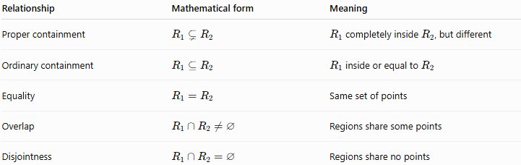
Relationship | Mathematical form | Meaning
Proper containment | $$R_{1}⊊R_{2}$$ | $R_{1}$completely inside $R_{2}$, but different
Ordinary containment | $$R_{1}⊆R_{2}$$ | $R_{1}$inside or equal to $R_{2}$
Equality | $$R_{1}=R_{2}$$ | Same set of points
Overlap | $$R_{1}∩R_{2}≠∅$$ | Regions share some points
Disjointness | $$R_{1}∩R_{2}=∅$$ | Regions share no points

Proper Region Containment in Different Dimensions
# Source: AI Source: Provided by: [Data Path: Persons Table -> ID Column: 1, Name_En Column: Motasem Essam] -> From: [ChatGPT] on [7/25/2026]
The same principle applies to different geometric settings.
2D
$$R_{1}⊊R_{2}$$
where both are planar regions.
3D
For volumetric regions:
$$V_{1}⊊V_{2}$$
For example, a smaller solid sphere inside a larger solid sphere.
Region in a Plane
A planar region can also be properly contained in a plane:
$$\boxed{R⊊Π}$$
because the region occupies only part of the infinite plane.

Relationship with Region Containment
# Source: AI Source: Provided by: [Data Path: Persons Table -> ID Column: 1, Name_En Column: Motasem Essam] -> From: [ChatGPT] on [7/25/2026]
Region Containment is the general concept:
$$R_{1}⊆R_{2}$$
Proper Region Containment is a specific type:
$$\boxed{R_{1}⊊R_{2}}$$
Therefore:
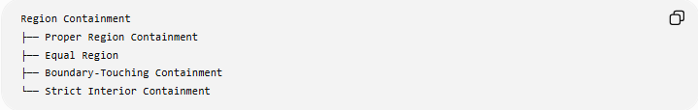
Region Containment
├── Proper Region Containment
├── Equal Region
├── Boundary-Touching Containment
└── Strict Interior Containment
Note that boundary-touching containment and strict interior containment describe additional geometric conditions and can overlap with proper containment.

Real-World Applications
# Source: AI Source: Provided by: [Data Path: Persons Table -> ID Column: 1, Name_En Column: Motasem Essam] -> From: [ChatGPT] on [7/25/2026]
Maps and Geographic Information Systems
A neighborhood boundary may be properly contained within a city boundary:
$$\text{Neighborhood}⊊\text{City}$$
Architecture
A room may be properly contained within the floor area of a building.
Computer Graphics
A smaller graphical object or region can be contained within a larger clipping region.
CAD
A component's geometric region may lie completely inside another object's region.
Robotics
A robot's workspace may be modeled as a region properly contained within a larger operating area.
Image Processing
A region of interest (ROI) may be properly contained within an entire image domain.

Key Points
# Source: AI Source: Provided by: [Data Path: Persons Table -> ID Column: 1, Name_En Column: Motasem Essam] -> From: [ChatGPT] on [7/25/2026]
- Proper region containment means one region is completely contained within another but is not equal to it.
- Its standard notation is:
$$\boxed{R_{1}⊊R_{2}}$$
- Every point of $R_{1}$belongs to $R_{2}$.
- At least one point of $R_{2}$does not belong to $R_{1}$.
- Proper containment is not symmetric.
- Proper containment is transitive.
- A contained region may or may not touch the boundary of the containing region.
- Strict interior containment is stronger than ordinary proper containment.

Conclusion
# Source: AI Source: Provided by: [Data Path: Persons Table -> ID Column: 1, Name_En Column: Motasem Essam] -> From: [ChatGPT] on [7/25/2026]
Proper Region Containment describes a relationship in which one geometric region occupies a genuine subset of another region:
$$\boxed{R_{1}⊊R_{2}}$$
It is therefore the appropriate concept whenever a region is entirely contained within another region without being equal to it. It provides a precise geometric way to describe nested regions, from circles and polygons in 2D to volumetric regions in 3D.

